**IST 659 Lab 4 SQL I**

**1. Create tables:**

**Create the five tables following the ERD above. Copy and paste the complete create statements to your lab report.**

**SQL CODE:**

--Create table Candidate with primary key as CandidateId

CREATE TABLE CANDIDATE(

CandidateId NUMERIC(10) NOT NULL,

CFName VARCHAR(20) NOT NULL,

CLName VARCHAR(20) NOT NULL,

CPhone CHAR(12) NOT NULL,

CStreetNo NUMERIC(5) NOT NULL,

CStreetName VARCHAR(20) NOT NULL,

CCity VARCHAR(20) NOT NULL,

CState VARCHAR(25) NOT NULL,

CZip NUMERIC(5) NOT NULL,

CExperience VARCHAR(50) NOT NULL,

CRelevantExp VARCHAR(50) NOT NULL

CONSTRAINT candidate_PK PRIMARY KEY(CandidateId)

);

--Create table Interviewer with primary key as InterviewerId

CREATE TABLE INTERVIEWER(

InterviewerId NUMERIC(10) NOT NULL,

IFName VARCHAR(20) NOT NULL,

ILName VARCHAR(20) NOT NULL,

IPhone CHAR(12) NOT NULL,

IEmail VARCHAR(30) NOT NULL,

IStreetNo NUMERIC(5) NOT NULL,

IStreetName VARCHAR(20) NOT NULL,

ICity VARCHAR(20) NOT NULL,

IState VARCHAR(25) NOT NULL,

IZip NUMERIC(5) NOT NULL,

ISchedule VARCHAR(100),

CONSTRAINT interview_PK PRIMARY KEY(InterviewerId)

);

--Create table COMPANY with primary key as CompanyID

CREATE TABLE COMPANY(

CompanyID NUMERIC(10) NOT NULL,

CompanyName VARCHAR(50) NOT NULL,

CompanyPhone CHAR(12) NOT NULL,

Companywebsite VARCHAR(50) NOT NULL,

CStreetNo NUMERIC(5) NOT NULL,

CStreetName VARCHAR(20) NOT NULL,

CCity VARCHAR(20) NOT NULL,

CState VARCHAR(25) NOT NULL,

CZip NUMERIC(5) NOT NULL

CONSTRAINT company_PK PRIMARY KEY(CompanyID)

);

--Create table POSITION with primary key as PositionID

CREATE TABLE POSITION(

PositionID NUMERIC(10) NOT NULL,

PositionName VARCHAR(50) NOT NULL,

PositionLevel VARCHAR(20) NOT NULL CHECK (PositionLevel IN('Internship', 'Entry', 'Staff', 'Managerial', 'Executive')),

PositionAvailable VARCHAR(50) NOT NULL CHECK (PositionAvailable IN('yes', 'no')),

CompanyID NUMERIC(10) NOT NULL,

CONSTRAINT position_PK PRIMARY KEY(PositionId),

CONSTRAINT position_FK FOREIGN KEY(CompanyID) REFERENCES COMPANY(CompanyID)

);

--Create table INTERVIEW with primary key as InterviewID

CREATE TABLE INTERVIEW(

InterviewID NUMERIC(10) NOT NULL,

RoundNumber NUMERIC(10) NOT NULL,

InterviewDate DATETIME DEFAULT GETDATE(),

CandidateId NUMERIC(10) NOT NULL,

InterviewerId NUMERIC(10) NOT NULL,

PositionID NUMERIC(10) NOT NULL,

CONSTRAINT interview_PK1 PRIMARY KEY(InterviewID),

CONSTRAINT interview_FK1 FOREIGN KEY(CandidateId) REFERENCES CANDIDATE(CandidateId),

CONSTRAINT interview_FK2 FOREIGN KEY(InterviewerId) REFERENCES INTERVIEWER(InterviewerId),

CONSTRAINT interview_FK3 FOREIGN KEY(PositionID) REFERENCES POSITION(PositionID)

);

**2. Insert data: Insert the following data (shown in the screenshots) to the tables. Copy and paste all insert statements to the lab report**

--Insert data into table CANDIDATE

INSERT INTO CANDIDATE VALUES

(1, 'Nathan', 'Kerr', '315-555-5555', 112, 'Lafayette Rd', 'Syracuse', 'New York', 13205, 'Database, Business Analysis', 'Database'),

(2, 'Sebastian', 'Cameron', '315-555-6666', 17, 'James St', 'Syracuse', 'New York', 13210, 'Consultant, Business Analysis', 'Consultant' ),

(3, 'Heather', 'Cameron', '315-555-7777', 410, 'Comstock Ave','Syracuse', 'New York', 13210, 'Developer, Business Analysis', 'Developer' ),

(4, 'Olivia', 'Wallace', '315-555-8888', 4248, 'Nottingham Rd', 'Syracuse', 'New York', 13244, 'Database, Business Analysis', 'Database'),

(5, 'Lily', 'Tumer', '315-556-9999', 3, 'Ostrom Ave', 'Syracuse', 'New York', 13225, 'Database, Business Analysis, Developer, Analyst', 'Database')

--Insert data into table INTERVIEWER

INSERT INTO INTERVIEWER VALUES

(1, 'Dorothy', 'Paige', '315-555-0126', 'dorothy.paige@syr.edu', 137, 'Sumner Ave', 'Syracuse', 'New York', 13210, '9am-5pm Monday-Friday'),

(2, 'Amy', 'May', '315-5555', 'amy.may@syr.edu', 777, 'Ackerman Ave', 'Syracuse', 'New York', 13210, NULL),

(3, 'Charles', 'Duncan', '315-444-5555', 'charles.duncan@syr.edu', 345, 'Lancaster Ave', 'Syracuse', 'New York', 13210, '8am-6pm Monday-Saturday'),

(4, 'Victor', 'Miller', '315-333-5565', 'victor.miller@syr.edu', 7116, 'Layfayette Ave', 'Syracuse', 'New York', 13205, NULL),

(5, 'Ray', 'Myste', '315-129-5677', 'raymesterio@syr.edu', 236, 'Layfayette Ave', 'Syracuse', 'New York', 13205, '9:30am-5:30pm Monday-Friday');

--Insert data into table COMPANY

INSERT INTO COMPANY VALUES

(1, 'Ernst & Young', '315-129-5677', 'www.ey.com', 234 , 'Lafayette Rd', 'New York', 'New York', 13205),

(2, 'Deloitte', '315-356-5887', 'www.deloitte.com', 456, 'Summer Ave', 'New York', 'New York', 13100),

(3, 'PWC', '315-894-4787', 'www.pwc.com', 791, 'Maryland Ave','New York', 'New York', 13801),

(4, 'KPMG', '315-129-5677', 'www.kpmg.com', 437, 'Lanchaster Ave', 'New York', 'New York', 12147),

(5, 'Cognizant', '315-479-5182', 'www.cognizant.com', 825, 'Ackerman Street', 'New York', 'New York', 10071);

--Insert data into table POSITION

INSERT INTO POSITION VALUES

(1, 'Technology Analyst', 'Internship', 'yes', 1 ),

(2, 'Business Analyst', 'Entry', 'yes', 1 ),

(3, 'Database Analyst', 'Executive', 'yes', 2 ),

(4, 'Risk Manager', 'Executive', 'no', 3 ),

(5, 'Advisory Consultant', 'Staff', 'yes', 4 ),

(6, 'Project Manager', 'Managerial', 'no', 5 );

--Insert data into table INTERVIEW

INSERT INTO INTERVIEW(InterviewID, RoundNumber, CandidateId,InterviewerId, PositionID) VALUES

(1, 2, 1, 1, 1 ),

(2, 1, 2, 2, 2 ),

(3, 3, 3, 3, 1 ),

(4, 2, 1, 2, 1 ),

(5, 5, 5, 5, 5 );

**CANDIDATE**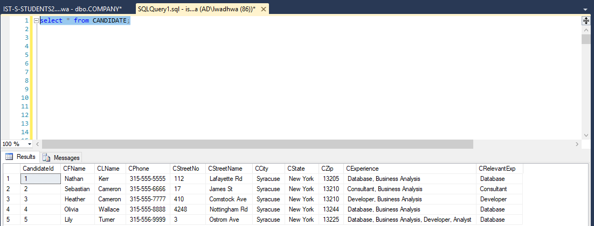

**INTERVIEWER**

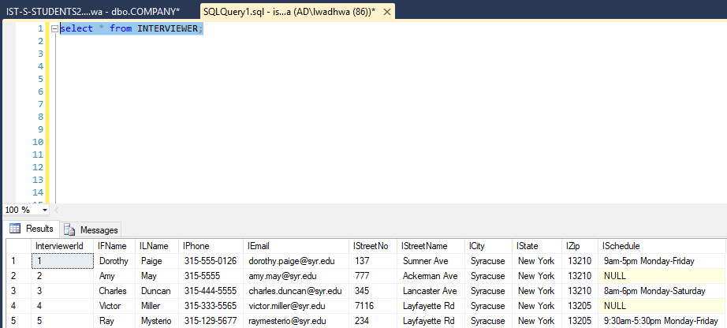

**COMPANY**

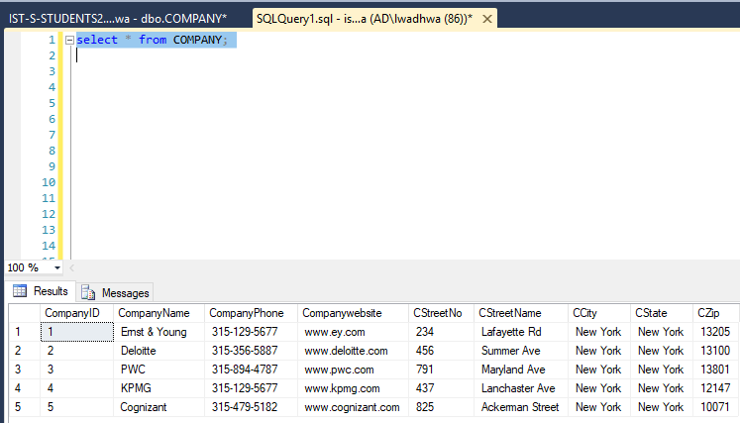

**POSITION**

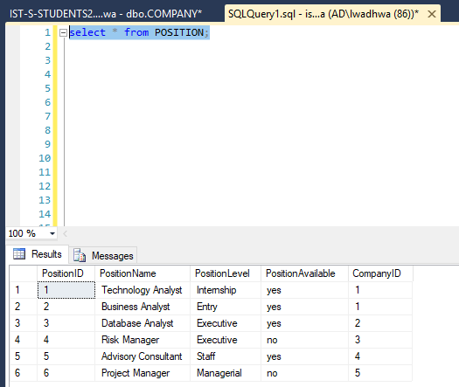

**INTERVIEW**

